Impact Report
2022

Impact Report 2022
1. About Mada 5
1.1. CEO of Assistive Technology Center - Mada 5
1.2.Mada’s Strategy 2022-2024 6
2.Education and Training 8
2.1.Introduction………………………………………………………………………………………………………8
2.2. Mada Academy:……………………………………………………………………………………………….8
2.3. Empowering institutions and individuals with basic competencies in ICT accessibility: Launching Mada ICT-AID Competency Framework 8
2.4.Promoting equitable access and inclusive education: Launching the Mada ICT-AID Competency Framework OER Hub 9
2.5.Digital Accessibility in Education Sector 10
2.6.Assistive technology support in the Education Sector 11
2.7.Training and Capacity Building Statistics Open Training Program 12
3.Community……………………………………………………………………………………………………………14
3.1. Introduction……………………………………………………………………………………………………14
3.2. Statistics of digital accessibility services Consulting Sessions 15
3.3. Training and Capability Building 16
3.4. Statistics of Digital Accessibility: Digital Government outcome 2022 16
3.5. With the aim of empowering persons with disabilities through assistive technology services………………………………………………………………………………………………16
3.6.“Bu Hamad” the first virtual interpreter for the Qatari sign language on the screens of Msheireb Downtown Doha :Developed by Mada Center 17
3.7. Lazarillo……………………………………………………..………………………………………………….17
3.8. Assistive Technology Services 18
4.Employment Sector 19
4.1. Introduction……………………………………………………………………………………………………19
4.2. Statistics of digital accessibility services 19
4.3. Measuring the impact of the “Access to employment” program 20
4.4. A success story of the first person with visual impairment in the Government Leadership Program…………………………………………………………………………………………….23
5. Policies…………………………………………………………………………………………………………………24
5.1. Introduction……………………………………………………………………………………………………24
5.2. Mada Center launches the ICT Accessibility Policy Portal: The Inclusive digital platform for digital accessibility policies 24
5.3. Publications by Mada Center within the framework of raising awareness in the field of digital accessibility policies and promoting digital inclusion for institutions and individuals…………………………………………………………………………………..26
5.4. Focus Sessions with Persons with Disabilities 26
6. Innovation…………………………………………………………………………………………………………….27
6.1. Introduction……………………………………………………………………………………………………27
6.2. The Launch of Mada Lab………………………………………………………………………………..28
6.3. The Launch of Mada Innovation Club 29
6.4. Mada Innovation Award………………………………………………………………………………….30
7. Research………………………………………………………………………………………………………………31
7.1. Introduction……………………………………………………………………………………………………31
7.2. Mada Edge……………………………………………………………………………………………………..31
7.3. Research Projects………………………………………………………………………………………….32
7.4. Nafath…………………………………………………………………………………………………………….34
8.Raising Awareness 35
8.1.Introduction…………………………………………………………………………………………………….35
8.2.“Champions Award”………………………………………………………………………………………..35
8.3.Mada's participation in the World Innovation Summit for Healthcare "WISH" .36
8.4. Mada's distinguished participation in the Smart City Expo Doha 2022 and presented a visitor’s journey to an inclusive smart city 36
9.Digital Accessibility in the 2022 FIFA World Cup Qatar 37
9.1. Mada during the 2022 FIFA World Cup Qatar 37
10. Mada’s Partners 40
10.1. Arab ICT Accessibility Expert Group By Mada 40
10.2. Local Strategic Partners………………………………………………………………………………41
10.3. International Strategic Partners 42
10.4.Mada Lab Sponsors………………………………………………………………………………………42
10.5. International Consortium……………………………………………………………………………..43
10.6. ICT Accessibility Enablers 43

About Mada

CEO of Assistive Technology Center - Mada
Under the slogan, “Towards an inclusive smart future” and out of our belief in the latent capabilities of persons with disabilities, their effective role in achieving the goals of sustainable development, and as they are an integral part of this society, we work with passion, hand in hand with them, to find out all their needs and requirements, and support them fully to enable them unlock their potentials and capabilities, ensure their independence, and fully integrate them into all aspects of life.
Based on this noble goal, the Assistive Technology Center - Qatar (Mada) was keen to launch its 2022-2024 strategy, through which we seek to establish a number of smart partnerships locally, regionally and internationally, in the sectors of education, community, and employment, through which we aim to support and enable our strategic partners in the field of digital accessibility. We are also working to support and improve digital access policies in government institutions, to ensure the right of PWDs to access digital content. We offer a number of consultations in the field of digital accessibility, technological solutions and assistive technology, and we specialize in applying digital accessibility standards and adopting digital platforms according to international standards.
We also offer training programs for PWDs to improve their technological skills, and accredited, high-quality training programs for experts and specialists. In addition to packages of assistive technology services for the purpose of assessing the needs of PWDs and providing them with assistive technology solutions.
“We are working to develop an ecosystem that supports the development of technological solutions in Arabic through the Mada Innovation Program”.
We empower innovators with disabilities with the necessary skills and knowledge to transform their ideas into solutions and products through Mada Innovation Club.
In the framework of activating Mada’s 2022-2024 strategy, we are pleased to launch “Mada Edge”, through which we work to develop research in Arabic, and resources on ICT accessibility, related products and solutions, the latest trends, international best practices, and related programs and policies. “Mada Lab” was also launched to be an innovation forum for innovators, entrepreneurs, and those interested in the technology of the 4th industrial revolution, such as artificial intelligence, the Internet of things, and robots to serve PWDs.
CEO of Assistive Technology Center - Mada

Mada’s Strategy 2022-2024
- Mission
Empowering persons with disabilities to participate and live independently through fostering the ecosystem of ICT accessibility.
- Vision
Enhancing ICT accessibility for persons with disabilities in Qatar and beyond.

- Our Values
- We are pioneers in innovating, customizing, and aligning ICT accessibility solutions to enable our local, regional, and international partners.
- We work with passion and positivity to understand the needs of PWDs to address them meaningfully.
- We work with the quality, agility, and flexibility needed to ensure Mada's success as a Center of Excellence.
- We build our relationships on trust and maintain continuous and effective communication internally and with our partners.
- We take collective ownership and support each other to achieve our common objectives and deliver with impact.
- Mada’s Priority Strategic Sectors
- Education: Mada Center works to enhance digital education opportunities for persons with disabilities through information and communication technology.
- Community: Mada Center works to empower persons with disabilities to live independently and participate in society by advocating for digital accessibility policies, developing ICT accessibility solutions in Arabic, and capability building.
- Employment: Mada Center works to enhance employment, professional development and entrepreneurship opportunities for persons with disabilities by upgrading their capabilities in information and communication technology and enhancing their self-confidence.

Education and Training

Introduction
In order to promote the concept of inclusive digital education to support students with disabilities and enable teachers, Mada Center launched a number of initiatives in 2022.

Mada Academy:
Mada Academy is an initiative by Mada Center to provide training and capability building with the aim of empowering all individuals and institutions and improving the digital access ecosystem by developing knowledge and professional competencies for all. Mada Academy offers programs, activities, and training content that are digitally accessible in various fields and specializations, within Mada ICT-AID Competency Framework, with a focus on ICT and digital inclusion, in addition to offering services in the fields of counseling, support, and preparation for the labor market.

Empowering institutions and individuals with basic competencies in ICT accessibility: Launching Mada ICT-AID Competency Framework
The Mada ICT-AID Competency Framework (ICT-AID) is a reference framework that identifies all competencies and capabilities required to enhance the understanding of ICT accessibility and direct the training of students, educators, and professionals to acquire basic and specialized competencies to use and develop accessible digital products, content, and services.
The framework can be used by educational institutions, organizations, and individuals to identify required competencies in the field of ICT accessibility and inclusive design and to promote the inclusion of ICT accessibility in training programs and education curricula.
A website was developed for the Competency Framework containing all its details and several related courses and publications.
The Mada ICT-AID Competency Framework was included in the Open Educational Resources platform (OER Commons) as a standard available to all users.

Promoting equitable access and inclusive education: Launching the Mada ICT-AID Competency Framework OER Hub
In support of the right of PWDs to access inclusive education, and out of our understanding of the important role played by open, digitally accessible educational resources, Mada Center launched the Mada ICT-AID Competency Framework OER Hub, which includes collections of digitally accessible open educational resources.
The resources were developed according to Mada ICT-AID Competency Framework. The hub serves the inclusive education community, access experts, teachers, learners, and others, as it aims to enable them to enhance their capabilities in the field of digital inclusion.
The Mada OER Network is listed on the OER Commons global platform OER Commons global platform

Digital Accessibility in Education Sector
Students and teachers’ accessibility to digital information and educational services has been improved to 89.8% in 2022, through the provision of 12 consulting sessions on ICT accessibility equal to 25 hours.
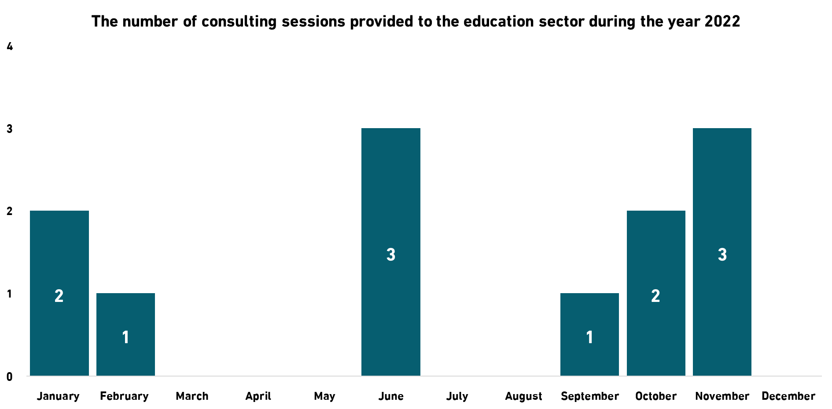
- (5) Reports prepared and issued to assess ICT accessibility to the education sector during the year 2022.
- Websites and applications accredited in the Education Sector in 2022:
- Tariq Bin Ziad School the Tariq Bin Ziyad School website was accredited on May 18, 2022, Tariq Bin Ziad School Website - Homepage
- Qatar Academy for Science and Technology the Qatar Academy for Science and Technology website was accredited on July 6, 2022, Qatar Academy for Science and Technology website - Homepage
- Renad Academy the Renad Academy website was accredited on May 18, 2022, Renad Academy Website - Homepage
- Qatar Leadership Academy the Qatar Leadership Academy website was accredited on November 17, 2022, Qatar Leadership Academy website - Homepage

Assistive technology support in the Education Sector
- Ensuring an inclusive learning environment for Student with disabilities Mada assistive technology stations:
Students with visual impairments have been enabled to access educational materials and participate effectively in the classroom environment, through the provision of an assistive technology station in Al-Yarmouk School, which will serve 4 schools affiliated to the Ministry of Education and Higher Education.
As a result of the launch of the assistive technology station in Al-Yarmouk School, the number of assistive technology stations in the Educational Sector has reached 22, aiming to serve students with disabilities, provide basic assistive technology needs and facilitate their access to direct technological support.
In order to empower students with disabilities, 6 Qatari and 9 non-Qatari students were assessed in the Education Sector to determine their needs for assistive technology solutions, and 11 students were provided with assistive technology solutions to support inclusive education.
Mada AT Portal - Where to try Assistive Technology in Qatar
- Keeping up with global developments in the field of assistive technology visits to assess and improve Mada stations for Assistive Technology.
In order to follow up on the work and effectiveness of the assistive technology stations to evaluate their impact, and to consider the possibility of modernizing them, a field visit was made to the two assistive technology stations in the two schools of Al-Hedaya (Al-Sakhama / Al-Masila). Assistive technology stations were also evaluated in specialized schools, Roaa Center and Qatar Community College. A report was issued about the impact of these stations on students with disabilities and how to improve them.

Training and Capacity Building Statistics Open Training Program
- 98.75% Satisfaction Rate
- 726 Trainees
- 112 Training Hours
- 37 Training Workshops
- 4 Persons with disabilities who have been trained.
- Training programs on the requirements of the 4th Industrial Revolution to enable the inclusive digital education sector in Partnership with the Ministry of Education and Higher Education and Mada Center
Within the “Tamheen” program held by the Educational Training and Development Center at the Ministry of Education and Higher Education, Mada Center participated in the training of 14 trainees of teachers and educators affiliated with the Ministry by providing 8 training workshops for 36 training hours.
Within the framework of the specialized training program dedicated to building the capabilities of the employees of the Ministry of Education and Higher Education, a training workshop entitled "Introduction to Disability and Accessible Digital Solutions" was held. The number of participants from various educational disciplines, including additional support, was 18 in-person and 327 remote trainees.
- Implementation of the latest educational programs that promote inclusion in education, "Minecraft Education Program", in cooperation with Microsoft Recreating Education Through Minecraft Educational Program for Teachers And Students"
In cooperation between Mada Center and Microsoft, a competition was launched under the title “Recreating education through the educational program "Minecraft - for teachers and students“. A training program for 6 female teachers was held at Mada Lab along with "remote" training workshops for teachers and students.
The competition for recreating education through the Minecraft educational program was also launched for teachers and students, as they designed interactive and fun educational lessons using the Minecraft tool.
- Mada Summer Camp "Health for All" To encourage creativity and innovation for students with disabilities Mada Center presented a series of training workshops entitled "Summer Camp, Health for All”.
Mada Summer Camp 2022 aimed to promote the concept of innovation for students with disabilities through the use of the latest technological solutions.
The summer camp touched on several topics, including: the basics of innovation, learning about the latest technology solutions, scientific research, as well as how to create a simplified scientific project in which students with disabilities between the ages of 12 and 15 years who have an interest in technology and innovation participated.

Community

Introduction
Mada Center worked to create an equal opportunity for persons with disabilities in order to live independently and participate in cultural life through accessible ICT by launching a number of initiatives in 2022.

Statistics of digital accessibility services Consulting Sessions
Access to information and digital services for persons with disabilities was improved by 88.9%, which contributed significantly to ensuring their effective participation in the community through the provision of 21 consulting sessions in the field of ICT accessibility for 42.5 hours.
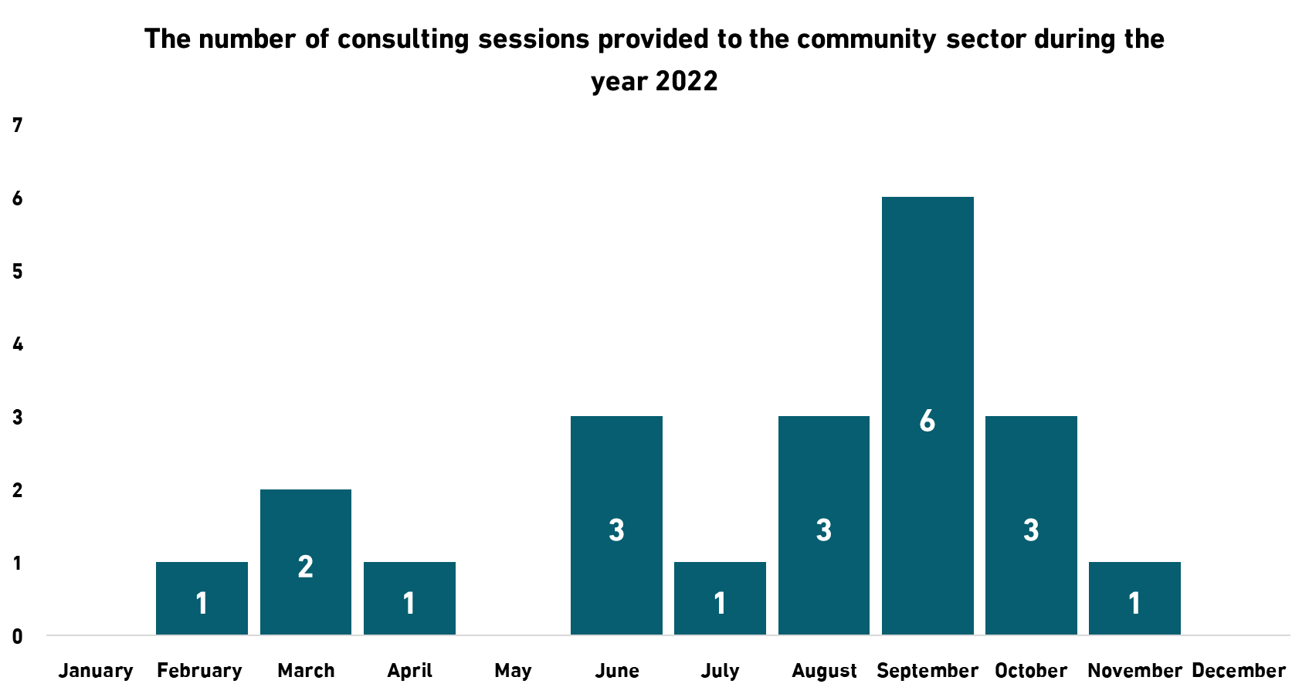
- (11) Reports prepared and issued to assess the accessibility of information and communication technology to the community sector during the year 2022.
- Websites and Applications accredited on the Community Sector in 2022:
- Shura Council The Shura Council website was accredited on September 27, 2022 Shura Council website - Homepage
- The Qatar National Library application was accredited on September 20, 2022.
- Hukoomi website re-accredited on December 21, 2022. Hukoomi Website - Homepage
- The Communications Regulatory Authority application “Arsel” was accredited on September 27, 2022.

Training and Capability Building
The actual participation of persons with disabilities in society has been improved by raising awareness of the importance of digital accessibility and building the capabilities of employees in various sectors in this field through the Mada training program. 269 persons were trained through 23 specialized training workshops on digital accessibility, assistive technology, and inclusive culture, with a total of 73 training hours, and a satisfaction rate of 97.84%.

Statistics of Digital Accessibility: Digital Government outcome 2022
- 50 Consulting sessions
- 37 Assessment Reports
- 9 Accreditation

With the aim of empowering persons with disabilities through assistive technology services
With the aim of enabling persons with disabilities through assistive technology services, Mada Center assessed 6 Qataris in the Community Sector to determine their needs for assistive technology solutions. 4 people were provided with assistive technology solutions to support their independence.

“Bu Hamad” the first virtual interpreter for the Qatari sign language on the screens of Msheireb Downtown Doha :Developed by Mada Center
- Mada Center developed "Bu Hamad", the first virtual interpreter for the Qatari sign language, which ensures digital inclusion for the deaf, facilitates their access to digital content in both Arabic and English, and enhances their integration into society.
- Within the framework of the strategic partnership with "Msheireb Properties", "Bu Hamd" innovation has been integrated in the visual advertisements displayed on the outdoor screens in Msheireb, as well as the internal display screens in the "Msheireb Galleria" shopping center, in line with the activities of the Qatar World Cup 2022.
- The virtual interpreter translates texts written in Arabic into Qatari sign language to invite the deaf to download the “Msheireb” application to learn about the activities associated with the Qatar World Cup 2022 and the activities of Msheireb.

Lazarillo
- To ensure an inclusive entertainment and shopping experience for persons with visual impairments and the blind Mada launches “Lazarillo “way-finding solution for the first time in Arabic in cooperation with Qatar Railways Company (Rail) and Msheireb Properties.
- Mada Center has localized and Endorsed the way-finding application "Lazarillo", as the application provides freedom of movement easily, safely and independently for persons with visual disabilities, which enhances their integration into society and guarantees their right to move and enjoy all tourist destinations and shopping places by using the application on their smart phones and without the need to connect to the Internet. The application works through voice instructions that allow users to get directions and navigate without the need for any assistance and in a completely safe environment.
- With the aim of enhancing the independence of persons with visual impairments and the blind when moving around inside closed buildings, and in strategic partnership with Msheireb Properties, the installation and activation of the way-finding application "Lazarillo", in Msheireb Galleria has been completed to provide an inclusive and safe shopping opportunity for blind and visually impaired person.
- Lazarillo” has also been installed and activated at Msheireb Metro Station, as part of the strategic partnership with Qatar Railways Company (Rail). The project aims to facilitate the free and independent movement of blind and visually impaired persons in the metro station.

Assistive Technology Services
With the aim of enabling persons with disabilities through assistive technology services, Mada Center assessed 6 Qataris in the Community Sector to determine their needs for assistive technology solutions. 4 people were provided with assistive technology solutions to support their independence.

Employment Sector

Introduction
Mada Center seeks to enable persons with disabilities and prepare them for the labor market in line with the requirements of this market by launching a number of initiatives in 2022.
To ensure that persons with disabilities have access to assistive technology to support their independence and in order to implement Article 9 of the convention on the rights of Persons with Disabilities "Accessibility".
Mada Center assessed 2 Qatari and 5 non-Qatari persons in the Employment Sector in 2022 in order to determine their needs for assistive technology solutions that would enable them to perform job duties.
With the aim of improving and developing the process of supporting employment and ICT accessibility in the employment sector, we have provided 3 persons with different assistive technology solutions.

Statistics of digital accessibility services
- 3 Consulting Sessions
- 4 Assessment Reports
- Websites and applications accredited in the Employment Sector in 2022
  - Ministry of Social Development and Family The website of the Ministry of Social Development and Family was accredited on December 27, 2022, Ministry of Social Development and Family website - Homepage

Measuring the impact of the “Access to employment” program
- Success Stories
In 2017, Mada Center launched an important initiative called the "Access to Employment Program" in partnership with the Ministry of Administrative Development, Labour and Social Affairs. The main purpose of which was to empower, support, guide, and train persons with disabilities through assistive technology to become able to work.
The program is based on identifying the individual educational and training disabilities and needs of each trainee and ensuring a safe, comfortable and enjoyable learning environment, 30 persons with disabilities were trained. Training topics included basic computer skills, management, customer service and communication skills. Each trainee was evaluated by assistive technology specialists to determine the suitable and supportive assistive devices to carry out the work tasks assigned to them.
- Saud Al-Shammari - Assistant receptionist in a school
"Thank you, Mada Center. The Center has helped me achieve my ambition to become a productive person in the society like my peers," says Saud Al-Shammari, a 23-year-old Qatari young man who uses a wheelchair. He has had cerebral palsy since birth, affecting his ability to speak and move his entire body except for the head. Saud has outstanding people skills and a genuine interest in helping others.
"Thanks to my enrollment in the “Access to Employment” Program, I am now working as an assistant receptionist in a school affiliated with the Ministry of Education and Higher Education, and I am very happy with my work and my achievement."
At first, Saud was referred to Mada Center, which formed a specialized team to assess his educational and technological needs through several sessions to identify appropriate assistive solutions for him. Saud lacked writing and reading skills and was unable to use a computer. As part of the Mada team's intervention to deal with his special case, he was provided with the “Clicker” educational program, which helped him to read and write using keyboards and mouses modified according to his limited mobility, which enabled him to use the computer, acquire typing skills, and use Microsoft Office. Saud was later enrolled in the “Access to Employment” Program launched by Mada Center in partnership with the Ministry of Administrative Development, Labor and Social Affairs, where he was trained for three months on communication skills and office work skills. Mada's team continues to assess and monitor Saud's needs in his new job to provide him with everything he needs to guarantee his full integration and independence, and to enhance his self-confidence as a productive and active member of his society.
- Dana Al-Baker - An official in the health sector
Dana Al-Baker is an ambitious employee in the health sector. She joined the “Access to Employment” program as she was visually impaired. Like other trainees, she received extensive and specialized training in customer service, secretarial work, and the use of basic computer programs.
“The information I obtained in the program was very useful, and the training was distinguished and accessible to all, and I thank Mada very much for providing me and my fellow persons with disabilities with this precious opportunity.”
During the program, Dana's needs were assessed and assistive technology devices were suggested to ensure she could carry out all the required tasks. After the completion of the training program, Dana joined the labor market, and today she can perform her job tasks efficiently and skillfully using the skills and knowledge she acquired in the “Access to Employment” Program.
- Aisha Khalfani innovation cooranidinator at Mada Center
“I feel very proud that I work today at Mada as an innovation coordinator and contribute to improving the digital accessibility ecosystem.”
Aisha is one of the participants in the “Access to Employment” program, and she has a hearing disability. Through the program, she acquired basic computer, management, customer service, and communication skills.
Aisha added, "I would like to thank Mada very much, as I am grateful for all the efforts made by the Center to support us with training and assistive technology. I hope that the program will continue and that other programs will be introduced to ensure continued development after employment."

A success story of the first person with visual impairment in the Government Leadership Program
- Mada Center in cooperation with Qatar Leadership Center work to implement digital accessibility facilities on the Government Leaders Program
Mada Center worked with the Qatar Leadership Center to facilitate the training program for the Government Leadership Program by working on applying digital accessibility standards to the program’s content to meet the needs of all persons with disabilities affiliated with the program. This had a clear impact on the participation of Mr. Muhammad Al-Fhieda, who is one of the distinguished blind employees of the Mada Center, as he says about his experience:
“My work at Mada Center had a major role in refining my skills and developing my knowledge. It also had an important role in building and developing my abilities and helping me to accomplish all the tasks assigned to me as a media and publishing officer at the Center. Mada has contributed to my enrollment in many training programs, the most important of which is the Government Leadership Program, and they supported me to pass the program successfully, through their approval to enter the program and giving me the time needed to focus on achieving this goal.
“The application of digital access standards made me able to interact with the program, which lasted a full year, as I was provided with all scientific materials in a format compatible with a screen reader.”
" My experience of passing the Government Leadership Program was one of the most wonderful experiences I have had during my professional career, and that was through the suggestion of the CEO of Mada Center for me to enter this program that aims at developing leadership skills, enhancing strengths and addressing weaknesses. I passed the entrance exams to select the best candidates for the program, including personal and general questions to determine my level. The number of applicants was 400, and I was chosen along with 40 other persons, and I was the only blind person qualified to enter the leadership program.”

Policies

Introduction
Policies guarantee the rights of persons with disabilities to access digital content in complete independence, and define general frameworks for institutions and individuals to ensure equal opportunities for digital access for all.

Mada Center launches the ICT Accessibility Policy Portal: The Inclusive digital platform for digital accessibility policies
- Mada Center launched the ICT Accessibility Policy Portal, which is designed to be a comprehensive source of information and resources related to digital access policies at the national, regional and international levels. The portal includes links to relevant national, regional and international laws and policies, which educate users about the legal framework and supportive legislation that promotes the rights of persons with disabilities in the field of ICT.
The ICT Accessibility Policy Portal provides advisory services aimed at assisting the concerned authorities in developing and implementing effective digital accessibility policies. Training courses are also offered to increase awareness and develop the necessary skills among officials and policy makers in the field of digital accessibility policies for persons with disabilities.
- Mada Center works to support the adoption of ICT accessibility policies: To protect the rights of persons with disabilities
Mada Center has supported the right of digital accessibility by including it in the draft law of persons with disabilities and its executive regulations proposed by the National Committee for Women, Children, the Elderly and Persons with Disabilities. As a leading center in the field of digital access, Mada Center worked in cooperation with the Ministry of Communications and Information Technology on a project to update the national policy for digital accessibility, as a larger number of target areas were included in the policy to ensure accessibility for persons with disabilities through ICT.
Updates to the draft National Digital Accessibility Policy included expanding target areas to include websites, mobile applications, communications, media, digital content, assistive technology, procurement, and reasonable accommodation for persons with disabilities.
In addition, Mada Center participated in the second workshop on the “Arab classification of disability”, which was organized by the Ministry of Social Development and Family. Mada Center's participation in this workshop comes as part of the Center's efforts to exchange experiences, knowledge and successful practices in the field of disability classification.

Publications by Mada Center within the framework of raising awareness in the field of digital accessibility policies and promoting digital inclusion for institutions and individuals
  - The Guide to “Best Practices in Accessible Events”, which provides comprehensive guidance for organizing events in a way that ensures full accessibility and inclusion for persons with disabilities.
  - “A Guide to Digital Accessible Media” that highlights successful and innovative practices in making media accessible to persons with disabilities.
  - “Accessible Procurement”, which provides a practical framework for evaluating, selecting, and purchasing technology goods and services with an eye on accessibility.
  - “Training for Persons with Disabilities” which provides guidance on how to provide effective and inclusive training for persons with disabilities and the best practices applied in this field.

Focus Sessions with Persons with Disabilities
Out of our belief in the important role of persons with disabilities in identifying the gaps and difficulties they face, proposing, experimenting and adopting technological solutions that will improve their lives, integrate them into society and ensure their independence. Mada Center held focus sessions that included:

- Education Sector:
  - A focus session with (9) students with hearing disabilities on the reading skills assessment tool.
  - Two focus sessions to evaluate the Microsoft Reading Progress tool in the presence of (5) students with visual disabilities and (3) teachers with visual disabilities.
  - A focus session with (10) students with learning disabilities about the challenges facing students with learning disabilities.
- Community Sector:
- A focus session for (8) persons with visual impairments to try and evaluate the electronic “Misbaha”.
- A focus session for (7) persons with disabilities on developing a government portal for PWDs.
- An opinion poll study for (18) PWDs on the effectiveness of the emergency service for persons with disabilities.

Innovation

Introduction
By supporting innovation, Mada Center seeks to provide new and innovative ICT solutions to improve digital access and ensure that persons with disabilities have access to digital content and services.

The Launch of Mada Lab
Mada Lab is a state-of-the-art showcase featuring the latest cutting-edge assistive technologies and accessible solutions aimed at improving digital access for Persons with Disabilities in the Arabic speaking Region and beyond. Mada Lab serves as an Innovation hub for innovators, solution providers, users, and ICT & AT experts. Mada Lab is one of the most important outcomes of the Mada Innovation Program, which was designed to encourage innovators to find solutions in Arabic for persons with disabilities, and to increase their availability in the Arab world, through a set of grant programs and entrepreneurial support, to provide a mechanism to bring relevant innovative assistive technology, products and services aimed at improving access to the local and global market. This work can contribute significantly to improving the lives of persons with disabilities in Qatar and the Arab world and supporting their independence.
Mada Lab was established and divided into different and unique areas, as it combines an interactive environment with global experiences and the latest practices in the field of assistive technology and the promotion of the independence of persons with disabilities.
Until the year 2022, 14 local and international companies joined as sponsors of Mada Lab and showcased their latest innovations in the field of digital access and assistive technology. Mada Lab has become a leading platform for presenting innovative solutions that can benefit PWDs and enable the education, community and employment sectors. Mada also signed with the Korea Trade-Investment Promotion Agency “KOTRA” and the Taiwan Information Industry Institute as enablers of the digital sector.
Mada Lab contains an accessible Mada Fab Lab for PWDs, which is considered the first of its kind in the world, as it uses digital manufacturing and open knowledge to develop and enhance social innovation. This laboratory is considered a center.
for learning and innovation and is equipped with devices and equipment to convert ideas into real products, design prototypes for innovations, manufacture them and share them with the interactive community. The laboratory includes all the software and equipment that innovators need, in addition to a specialized team to provide technical advice to innovators to enhance their ideas and transform them into effective products in the assistive technology market. Mada seeks to achieve positive change and enhance productivity by integrating PWDs in society to build a new generation of manufacturers and innovators in the field of technology.

The Launch of Mada Innovation Club
The “Mada Innovation Club” was proudly launched by Mada Center, with the aim of enabling innovators with disabilities and transforming creative ideas into a tangible reality. Through the club's activities, the Center seeks to promote the creative culture of PWDs in society, encouraging them to develop their knowledge and skills, and launch effective and innovative products. Eight members of innovators with disabilities joined the Mada Innovation Club, representing various creative fields and interests. These innovators work together to develop their creative ideas, and to manufacture distinct products that are in line with their own needs and also meet the needs of the Qatari and Arab society.

Mada Innovation Award
- Competitions Stream:
Mada Center has developed and launched the Mada Innovation Award platform ( Mada innovation award website - Homepage ) It is the platform for announcing and opening registration for the Mada Innovation Award, which is the first award of its kind globally aimed at supporting the development of innovative solutions that enhance accessibility for persons with disabilities in various streams: supporting entrepreneurs, direct grants, Localization, and competitions. The door for nominations for the Mada Innovation Award and the Mada Hackathon has been closed, with the participation of 226 innovators distributed as follows:
- Mada’s Participation in the Hackathon:
Mada participated in the Artificial Intelligence and Digital Access Hackathon organized by the American University of Beirut. It also participated in the "48 Hours Programming Camp" Hackathon organized by the Digital Business Incubator through a special stream for Mada Center. The startup eHaris won the first place for its software for measuring the attention span of children with autism.
- “Sukoon” application:
The development of the initial version of the "Sukoon - Learn for Them" application was completed by the innovator Ramzan Al-Nuaimi, Innovation Café, and an assessment session was held and technical support was provided by recording 3135 videos in Qatari sign language at Mada Studio.
- “MindRace” Program:
The development stage of the “MindRace” program, which offers the ability to control computers by the brain, for the innovator Akram Al-Haidari, has been completed and presented in the innovation area of Mada Lab.
- 20 Localization Stream
- 74 Hakathon Stream
- 132 Direct Grant Stream
- 6 Innovators were declared winners.

Research

Introduction
At Mada Center, we work to improve and develop the digital infrastructure and provide equal access to information and digital services through supporting and developing relevant research and publications on ICT accessibility.

Mada Edge
Mada Center has launched “Mada Edge”, which specializes in leading the development of research related to addressing the challenges associated with developing research in Arabic. “Mada Edge” aims at leading the challenges related to the treatment of Arabic through research projects that support the ecosystem of the Mada Innovation Program, working on research programs, experiments and partnerships, with the aim of increasing and generating knowledge and data in Arabic to bridge the gap resulting from the lack of localized and scientifically proven solutions and sharing this knowledge with so that the outputs are more effective. Mada Edge programs aim to find and present evidence of what works (and what doesn't) in digital access and assistive technologies in Arabic.
The Mada Edge International Consortium was also established, and Hamad Bin Khalifa University and Muscat University joined.
The International Research Consortium is a formal collaboration that brings together individuals or organizations to address a common set of questions or goals using a defined structure and management model.
Mada Edge Portal - Homepage

Research Projects
- The first research project “Jumla Sign Language”
- The publication the world’s first database of Qatari sign language sentences “JUMLA-QSL-٢٢: A dataset of Qatari sign language sentences” in the IEEE DataPort under an open access license to prompt researchers around the world to work on research challenges related to machine sign language processing and machine recognition.
- The development of a tool to manage videos recorded in sign language: “Jumla Content Management System.”
- The publication of a scientific paper entitled Virtual reality for educating Sign Language using signing avatar The future of creative learning for deaf students.
- The publication of a scientific paper entitled Intra-linguistic and extra-linguistic annotation tool for the “Jumla Dataset” in Qatari sign language.
- The second research project
"Digital Inclusion of the Elderly and Caregivers in Qatari and Arab Families"
- Completion of the research project "Digital Integration of the Elderly and Caregivers in Qatari and Arab Families" funded by the Qatar Fund for Scientific Research and the Doha International Family Institute, where the preliminary results were presented on May 31, 2022 at Mada Lab, as well as during the expert group's preparatory meeting for the thirtieth anniversary of the International Year of the Family under the title of "Technological Change and the Family in the Arab Region" at the Arab League, Cairo.
- The publication of a scientific paper entitled Research on Older Persons’ Access and Use of Technology in the Arab Region Critical Overview and Future Directions
- The publication of a scientific paper entitled Addressing the Digital Gap for the Older Persons and their caregivers in the State of Qatar A Stakeholders’ Perspective.
- The publication of a scientific paper entitled Supporting digital inclusion for older citizens and their caregivers in Qatari and Arab Families A Pilot Study.

- The third research project
“Automatic Arabic Speech Recognition”
The publication of a scientific paper entitled “Automatic Arabic Speech Recognition: A Systematic Literature Review”, which aims to enrich this field.
by conducting a “Systematic Literature Review (SLR)” to give information on speech recognition technology, especially for Arabic. The aim is to shed light on the latest research trends on speech recognition technology in Arabic and guide researchers to the most important studies published during the past ten years 2011-2021.

Nafath
“Nafath’’ is a periodical published by Mada Center in Arabic and English on a quarterly basis. It aims to be a key information resource for disseminating the facts about latest trends and innovation in the field of ICT Accessibility. According to its role as a window of information to the world, it highlights the pioneering work done in our field to meet the growing demands of ICT Accessibility and Assistive Technology solutions and services in Qatar and the Arab region. During 2022, Mada issued the 19th edition on advanced technologies, the 20th edition on Bu Hamad, the virtual sign language interpreter, and the 21st edition, which dealt with inclusive education.
Nafath Portal - Homepage

Raising Awareness

Introduction
We have a responsibility to enhance the rank of the State of Qatar in the world in the field of ICT accessibility, and we work eagerly to promote the brand of the Mada Center to enhance the position of Mada as a Center of Excellence in digital access in Arabic in Qatar and the world.

“Champions Award”
- Mada won the “2022 Champions Award" of the World Summit on the Information Society WSIS
We are proud to have qualified through Mada Center's project "Enabling the Learning Environment through Assistive Technology" within the "Environmental Empowerment" stream to the final stage (Champions Stage) of the WSIS 2022 Awards at the International Telecommunication Union headquarters in Geneva.
Mada also participated in the series of virtual sessions of the Forum's activities by holding two accessible and inclusive virtual sessions with sign language interpretation and simultaneous translation, within the stream of ICT accessibility and accessibility for PWDs. The first Mada virtual session was held under the title “Capability Building in the field of ICT accessibility". The second session was titled "Linking Innovations to PWDs in line with the Sustainable Development Goals: An Overview of Mada's Innovation Ecosystem".

Mada's participation in the World Innovation Summit for Healthcare "WISH"
Mada Center participated in the World Innovation Summit for Healthcare WISH 2022, which was held at Qatar Foundation in Doha, with a live broadcast. And that was done through the virtual pavilion of Mada, through which the participants were introduced to all the Center’s digital and social media platforms, and they were invited to visit them to learn about all the services and activities provided by Mada.
The Center also participated in the discussion session on "Building Smart Cities to Improve the Health of Disabled Persons on the sidelines of its participation in the World Innovation Summit for Healthcare WISH 2022.

Mada's distinguished participation in the Smart City Expo Doha 2022 and presented a visitor’s journey to an inclusive smart city
Mada Center participated in the Smart City Expo Doha 2022 conference and exhibition entitled "A More Resilient Sustainable Future". The participation of Mada Center in this event came as a center of excellence in digital accessibility in Arabic language in the world. The Center developed and published the Accessibility Guide at Expo Doha Smart City Exhibition, which contained information about all the facilities and services available during the exhibition for persons with disabilities.
Through its pavilion in the researchers area of the exhibition, Mada Center presented its most important achievements in the field of innovation and digital accessibility research, which keep pace with the latest developments of the Fourth Industrial Revolution, in addition to highlighting the outputs and impact of the strategic partnerships concluded by the center and their role in empowering persons with disabilities.

Digital Accessibility in the 2022 FIFA World Cup Qatar

Mada during the 2022 FIFA World Cup Qatar
Mada Center implemented a number of projects and programs to improve the ecosystem for ICT accessibility in the State of Qatar during the 2022 FIFA World Cup Qatar.
- The First Project: Translating digital content into Qatari sign language
The first project is translating digital content into Qatari sign language using the avatar technology "Bu Hamad", which was applied to advertisements displayed in Msheireb Smart City. It is a virtual interpreter of Qatari sign language. It aimed to provide digital content in sign language so that persons with hearing disabilities can access content.
- The Second Project: Accessible Wayfinding Project
Mada also worked on the accessible way-finding project at Msheireb Galleria and the (Rail) Metro Station in Msheireb. Where the project aimed to enhance the independence of blind persons when navigating inside closed buildings through an accessible way-finding application.
- The Third Project: Qatari Money Reader Application
The Center also launched the updated version of the “Qatari Money Reader” application, which is the first of its kind in the State of Qatar, which employs the capabilities of modern technology to meet the needs of persons with visual impairments. The application aims to help persons with visual impairments to read and check banknotes independently During the FIFA World Cup Qatar 2022, the Ministry of Commerce and Industry circulated the application of the Qatari Money Reader to commercial centers and shops in order to facilitate the shopping process for persons with visual impairments.
- The Fourth Project: Accessible Museums "Mathaf"
In order to enable an equal base for persons with disabilities in order to participate in cultural life in accordance with the Arab identity through ICT, and in accordance with international best practices, Mada Center has developed the accessible museum project, as it aims to bring cultural monuments closer to the public in Qatar, in cooperation with the Arab Modern Art Museum in Qatar "Mathaf", within the strategic partnership with Qatar Museums.
The project included five accessible solutions and innovations applied in the museum: accessible way-finding for PWDs, 3D scanning technology, QR bar-coding, virtual tour, and museum tours using robots.
- The Fifth Project: Access to Digital Platforms
With the aim of improving access to digital platforms by fans and visitors with disabilities and the elderly during the World Cup, Mada Center worked in cooperation with specific institutions to improve digital accessibility to digital platforms, which included accrediting digital platforms such as websites, mobile applications, and self-service kiosks in addition to customer service points.
The project aimed to facilitate access to various information and services independently and to ensure an exceptional experience during the tournament.
- The Sixth Project: Accreditation of Automated Teller Machines (ATM)
The project aimed to collaborate with Qatar Central Bank (QCB) to improve ATMs access for fans, visitors with disabilities during the World Cup to ensure independent access to information and services and to ensure an exceptional experience during the World Cup.
Accessible ATMs enable persons with disabilities to conduct banking transactions in complete privacy and confidentiality.
- The Seventh Project: Evaluating the readiness of the stadiums hosting Qatar World Cup 2022
Mada Center worked with the Supreme Committee for Delivery and Legacy through the Accessibility Forum on the process of evaluating the readiness of the stadiums to host the Qatar World Cup 2022 by ensuring their accessibility and ability to receive fans and visitors with disabilities and provide an exceptional experience.
The Center also worked to build the capabilities of volunteers in dealing with persons with disabilities by providing two training workshops targeting 96 trainees, on best practices in dealing with the target groups, in addition to presenting the best assistive technology solutions and devices that would facilitate the process of dealing and communicating with visitors at the customer service point.
- A special event to enhance digital accessibility to the 2022 FIFA World Cup Qatar "Mada Center Initiatives" and the accompanying exhibition.
Mada Center held an introductory workshop entitled "Promoting Digital accessibility to the 2022 FIFA World Cup Qatar”, in which Mada ‘s initiatives to enhance digital access for persons with disabilities during the World Cup period were discussed and highlighted. The workshop was accompanied by an exhibition of innovations, through which all the various innovations that the center worked on in cooperation with its partners were presented.
The event aimed to introduce the Qatari community and beneficiaries with disabilities to innovations and solutions that would improve the visitor experience for persons with disabilities during the World Cup.

Mada’s Partners
We are proud of our partners in the journey of success.

Arab ICT Accessibility Expert Group By Mada
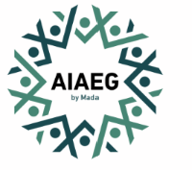

Local Strategic Partners
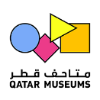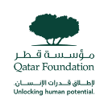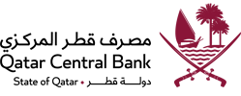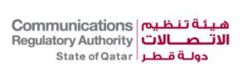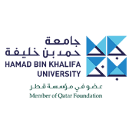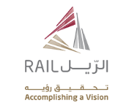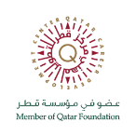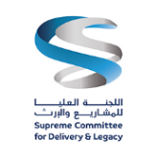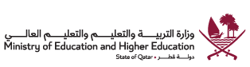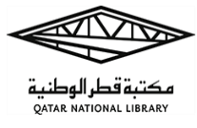

International Strategic Partners
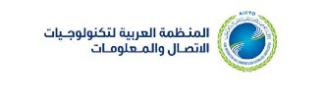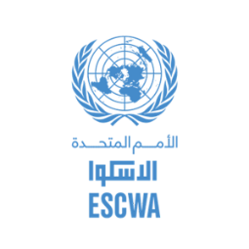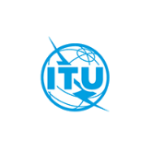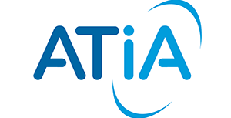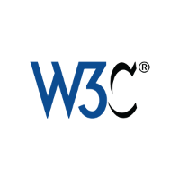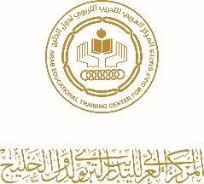

Mada Lab Sponsors
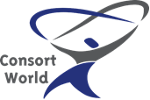

International Consortium

ICT Accessibility Enablers

